Design Report

System Design Report

Carrot Quest
Developers: Ariana Brown , James McGuigan , Steven Foster, Adan Solano ,Jugraj Samra

1. Introduction 5
1.1. Purpose of the System 5
1.2. Design Goals 6
1.2.1. Optimization of User Experience 6
1.2.2. Balanced Gameplay Dynamics 6
1.2.3. Improved visuals 6
1.2.4. Scalable 6
1.2.5. Performance 7
1.2.6. Accessibility 7
1.3. Performance 7
1.4. Background 8
1.5. Gameplay 8
1.5.1. Character Design and Mechanics 8
1.5.1.1. Character 8
1.5.1.2. Jump 9
1.5.2. Platforms 10
1.5.3. Objects 11
1.5.4. Game Implementation 11
1.6. Game Implementation Activity Diagram 14
1.6.1. Game Purpose 14
1.6.2. Activity Diagram 14
1.7. Definitions, Acronyms, and Abbreviations 14
2. Software Architecture 15
2.1. Subsystem Decomposition 16
2.2. Hardware/Software 17
The core design of Carrot Quest will be developed using Java. Specifically, the game itself will be made with JavaScript. The game will be run in a web browser and use HTML to assist with the visuals within the game.
Carrot Quest hardware is very accessible so users can play the game easily. The keyboard and mouse will be used as an input/output tool for the game. The keyboard and mouse allow players to interact and play Carrot Quest. The mouse is used to navigate the menu selection and game over screen. Players can click the menu selection to start the game, view instructions, look at high scores, enable or disable music, and exit the game. In the end screen section players can submit a score, restart the game, and return to the main menu. While playing the game players can use the “A” and “D” keys or arrows on the keyboard to move the bunny.
The score system will be stored within a local database. As a result, the game does not need any internet even to see the scoreboard. However, this also means highscores are unique to each computer. In the future Carrot Quest, plans to make the scoreboard universal, allowing players to compete with other players across the world. 17
2.3. Persistent Data Management 17
2.4. Access Control and Security 18
2.5. Boundary Condition 18
3. Subsystem Services 20
3.1. Game Logic and Design 20
3.1.1. Overview 20
3.1.2. In-Game State Activity (use case diagram here) 21
3.1.2.1. “Full activity diagram” of play →in game → game over 21
3.2. In-Game Scenarios 21
3.2.1. Continuous score accumulation 22
3.2.2. Sequence diagram updated 22
3.2.3. Death by Falling 23
3.2.4. Death by object bomb 23
3.2.5. Pause - in regards to “player needs to leave to go do stuff. 23
3.2.6. Quit the menu/ continue. 23
3.3. “Sequence Diagram” & “Deployment Diagram” with states objects and variables 24
4. Detailed Design 25
4.1. Properties of the Game 25
4.1.1. Player 25
4.1.2. Platforms 25
4.1.3. Bombs 26
4.1.4. Scenario 26
4.1.5. Background 27
4.1.6. Score 27
4.1.7. Difficulty 27
4.1.8. States 28
4.2. Methods of Design 28
4.2.1. Score based on height climbed. 28
4.2.2. Game loops 28
4.2.3. Event listeners keyboard 28
4.2.4. Background 29
4.2.5. Sounds 29
4.2.6. Menus 29
4.2.7. Buttons 29
4.3. Game Design 29
4.3.1. Functions 29
4.3.2. Objects 30
4.4. Methods 31
4.4.1. Place platform 32
4.4.2. New platform 32
4.4.3. Place object 32
4.4.4. New object 32
4.5. Player 33
4.5.1. Vertical Movement <<Access Matrix for this >> 33
4.5.2. Horizontal character movement <<Access Matrix for this >> 33
4.5.3. bounce<<Access Matrix for this >> 33
4.6. GUI Design 33
4.6.1. Description and Image of Components 33
4.6.1.1. Main page 34
4.6.2. Description and Image of Components 34
4.6.2.1. Info. 35
4.6.3. Description and Image of Components 35
4.6.3.1. Highscore 36
4.6.4. Description and Image of Components 36
4.6.4.1. Game screen 37
4.6.5. Description and Image of Components 37
4.6.5.1. Game over 38
4.6.6. Description and Image of Components 38
4.6.6.1. Restart & Exit 39
4.7. GuI Class Design 39
4.7.1. Description 39
4.7.2. “Class Design/Function Design Diagram” 40
4.7.3. “Activity Diagram Based on last” 40
4.8. Sound Design 40
4.8.1. Sound effects 40
4.8.2. Music 41
4.9. Backend 42
4.9.1. Highscore save states 42
4.9.2. Database 42

Introduction

Purpose of the System
Carrot Quest is an online 2D-platformer game that uses a vertically scrolling environment, the player takes control of a rabbit character and the game experience is aime to meet the will find the following criteria:
- Easy access: The game will be hosted on a web browser and has no installation requirement to play on the internet.
- User Engagement: The game engages the player with controls and gradually increases difficulty as the game cycle continues.
- Technical: Carrot Quest implements aspects of Web development, where the boundaries of HTML5, Stable Diffusion, CSS styling, and JavaScript game logic blend to build the game.
- Design: It was created to work fluidly with different dimensions of screen size and fit within the best gaming experiences on desktops and tablets.

Design Goals

Optimization of User Experience
- To design a user-friendly interface that will make navigation through menus
- Make use of game mechanics so long tutorials are not required.

Balanced Gameplay Dynamics
Challenges and possible achievements should be well-balanced to suit several types of players.
Visual Consistency using Stable Diffusion creates a visual art style, and it adds to the theme within the game structure to make it a flowing and continuous visual game design.

Improved visuals
- Include smooth animations and physics-based movements that would enhance gameplay.
- Optimize the graphical performance to make every effort to ensure high frame rates without sacrificing visual quality.

Scalable
- Design a modular system architecture that is easy to expand and integrate.
- Create a flexible level design framework to allow future game modes and content to be easily added.

Performance
- Emphasize resource management for smoother gameplay on a wide array of specified devices.
- Employ strategic loading and unloading of assets to keep memory usage low and decrease load times.

Accessibility
- Include options to change controls and difficulty levels so everyone can enjoy playing the game despite different skill levels.
- Include options for color-blind-friendly options and variable text sizes.

Performance
Performance is one of the major concerns in the development process of this game.
- It should be able to run at least 60 FPS on most devices.
- 60 FPS is achieved through rendering set within the JavaScript code.
- Compressed assets and asynchronous loading methods bring down the load times whenever possible.
- Carrot Quest, with a total file size under 50 MB for fast loading over slower internet.
- Performance tests are necessary for development to identify “bottlenecks” early and solve them.

Background
Carrot Quest is an endless jumper game mechanics and classic platformer gameplay using vertical scrolling like common mobile games. Its design is a friendly, browser-accessible game that encourages the user to set a high score and become top of the leaderboard.
The rabbit was chosen because of its aesthetic and appealing design of a simple pet-based platformer game. The design and theme of the game can add challenge to a simple vertical climbing premise, creating difficulty based on user experience while allowing the game world to be visually appealing. The vertical scrolling mechanic was inspired by mobile games and developed with specific intentions to work on PCs.

Gameplay

Character Design and Mechanics

Character

Carrot Quest’s character is a rabbit character that should be cute and attract players to the game.
- Visual Design:
  - A Rabbit is designed in a cartoon style but equally appealing to the viewer and has clear features.
- Multiple images (Sprites):
  - Different images for both left and right orientations enhance movement preview to the player, increasing the engagement level.
- Dimension:
  - The character has been fixed at 100x100 pixels to offer the best balance between viewability and maneuverability within the game.

Jump
Set variables define the jumping process of the rabbit.
- JUMP_FORCE: Set How High the character can jump.
- MAX_FALL_SPEED: Limits how the character can fall.
- Collision Detection: handles interaction with obstacles.
- Dynamic Positioning: Updates character position based on user input and game physics.
The positioning makes sure the characters respond in real-time while moving around during the game.

Platforms

The Platforms are designed for vertical user progression.
Requirements regarding dimensions:
- There can only be platforms with an exact size of 450x250 pixels.
- This platform size is specific to keep the players engaged while not being too difficult to maneuver and attempts are to keep progression balanced but not intrusive.
  - Procedural Generation: Automatic creation of platforms using algorithms
  - Vertical Distribution: Arrangement and spread of platform and object entities along our vertical axis.
  - Dynamic Array Management: resizing of arrays to accommodate variable sizes during runtime.
  - Memory Management: Infinite vertical progression of the player, while managing game performance.
  - Resource Management: asset management to prevent waste or overuse in-game improving memory management.
  - Collision detection: Identifying when the player and the objects interact.
  - Results: landing, jumping, score increasing counting vs. scorekeeping

Objects
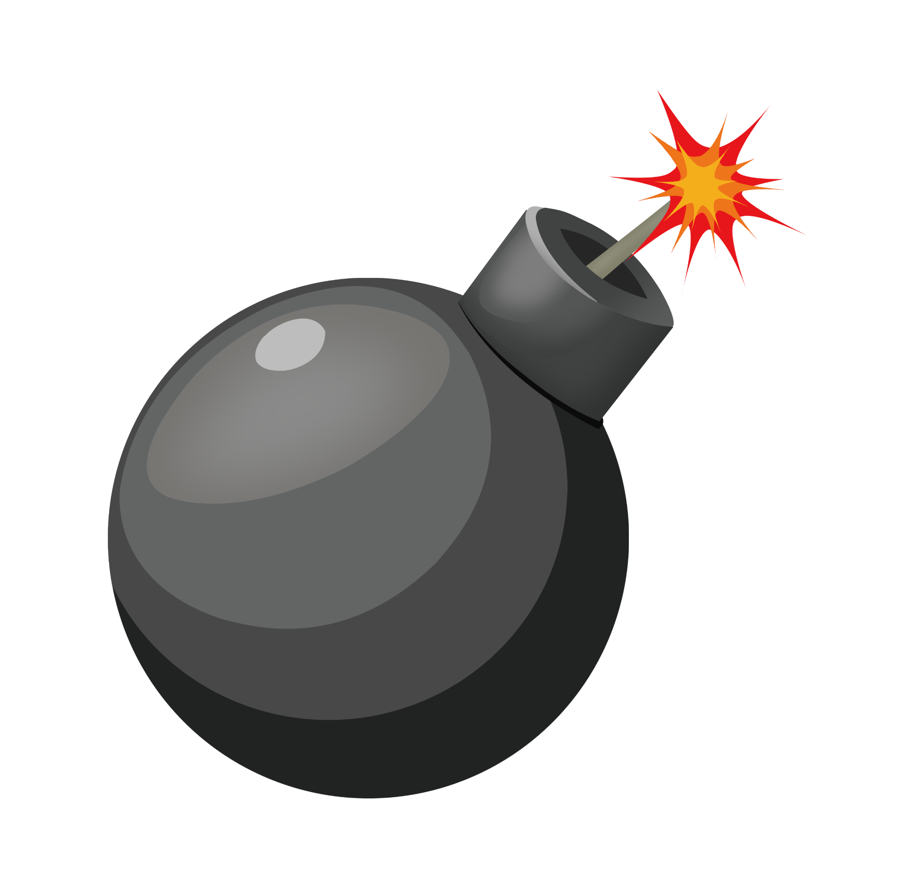
- Visual Presentation: This sets the ‘bomb.png’ image with dimensions of exactly 50x50 pixels.
- Positioning: These will be placed strategically at random within the game area, which requires players to be very careful moving.
- Array Management: Bombs are handled in a separate array from the platforms because they can be added or removed at any time and the objects present further challenges to the player.
- Consequence Collision: “Game Over” immediately from contact with a bomb adds a critical risk to the game's design.

Game Implementation
Technologies: HTML5, CSS, and JavaScript were chosen for this project with development intentions to become a fully functional web-based playable game. HTML5 provides the structure and canvas element for making the game. CSS styles the game's visual elements, creating an appealing and responsive interface.
- HTML5: We used HTML to create the game's structure and provide the canvas element for rendering graphics.
- CSS: The themes and styling of the game's visual elements, including the menu screens, buttons, and background to create the theme.
- Javascript: Used for the game logic, including character movement, collision detection, score tracking, and game state management.
Animation & effects: The game uses various animations and effects to attract the player and enhance the user experience. CSS animations are used for elements like the bouncing title on the menu screen to create an inviting atmosphere. In the JavaScript code, we included dynamic animations such as character movement and platform scrolling.
- FPS: This is set at 60fps to create seamless gameplay for the user increasing functionality and playability.
Main Game Loop: The update function utilizes the core aspects of the game by handling physics, collisions, rendering, and game state management. It uses requestAnimationFrame to continuously call itself, creating a smooth animation for seamless gameplay from play to restart to pause to play.
- Time Management: The function uses performance to calculate the time elapsed since the last frame. A delta time is computed to ensure consistent physics regardless of frame rate.
- Game State Check: The loop first checks if the game is playing and not paused. If not, it simply requests the next animation frame and returns.
- Physics Calculations/Movement:
  - Vertical Movement: Uses the gravity variable to the rabbit's vertical velocity, adjusted by a maximum fall speed.
  - Horizontal Movement: Adjusts the rabbit's horizontal velocity based on player input, applying acceleration and deceleration.
- Position: Updates the rabbit's position based on its velocity and screen wrapping for horizontal movement
- Collision Detection: Collisions between the rabbit and platforms, use the rabbit's bouncing, and detect collisions with obstacles.
Status Management
- gameState: The game state is managed using variables.
- isPaused: This state allows players to temporarily halt the game, check the menus, and adjust the volumes of the game and the character.
- gameOver: Triggers the end-of-game sequence and displays the final score and the selections for options such as replay, enter the name for the score menu or return to the title.
Tracking Scores: Tracking a high score is present within the game because we want to add a competitive nature to the gameplay while displaying our skill by integrating a backend into our project. The high score management system will use a simple counter that records name and score data based on the player's progress and performance. The score is updated in real-time during gameplay and displayed to all players of the web-based application game.
- High Score Management System

Game Implementation Activity Diagram

Game Purpose
The game is made to be fun and engaging for players. Our project focuses on competition, it encourages the player to place a high score and outperform their opponents.

Activity Diagram

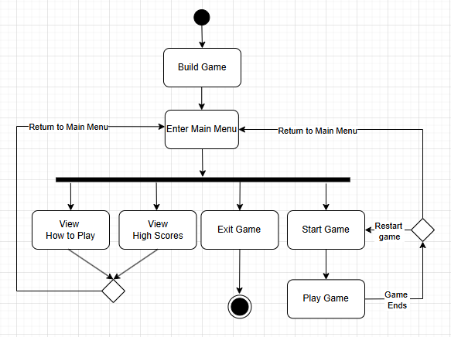

Definitions, Acronyms, and Abbreviations
HTML5: Hypertext Markup Language, used for structuring web content.
CSS Styling: Cascading Style Sheets are used to design the visual layout of web pages.
JavaScript: programming language used for creating dynamic content on web pages.
Stable Diffusion: Image-generating AI, used for the game to create consistent visual styles.
Scalability: allowing for the addition of new features without a major redesign of the project.
Modular System Architecture: dividing the system into separate pieces, making it easier to expand the game.
Resource Management: utilizing the memory during gameplay to ensure smooth performance
Asynchronous: operations that occur independently of the main game loop. This allows efficient loading of assets and reduces lag.
Bottlenecks: slow down performance and efficiency of the project development, which need to be identified and resolved.
Procedural generation: Utilizing an algorithm instead of manually assigning variables for the project environment.
Loops: The repeated set of instructions to update the game states.
State Transition: The change in the game’s status (playing, pause, main menu, etc.)
High Score Management System: System that tracks and displays player scores, and works with the backend to create records into a database.

Software Architecture

Subsystem Decomposition
Our goal when creating Carrot Quest is to reduce coupling. Reducing coupling makes sure that if one subsystem changes it does not affect the rest of the subsystem. We also want high coherence. By decomposing Carrot Quest we can break it down into simple and manageable components. Breaking it down allows debugging to be easier. It allows us the developer to focus on individual sections within the system and not the entire system.

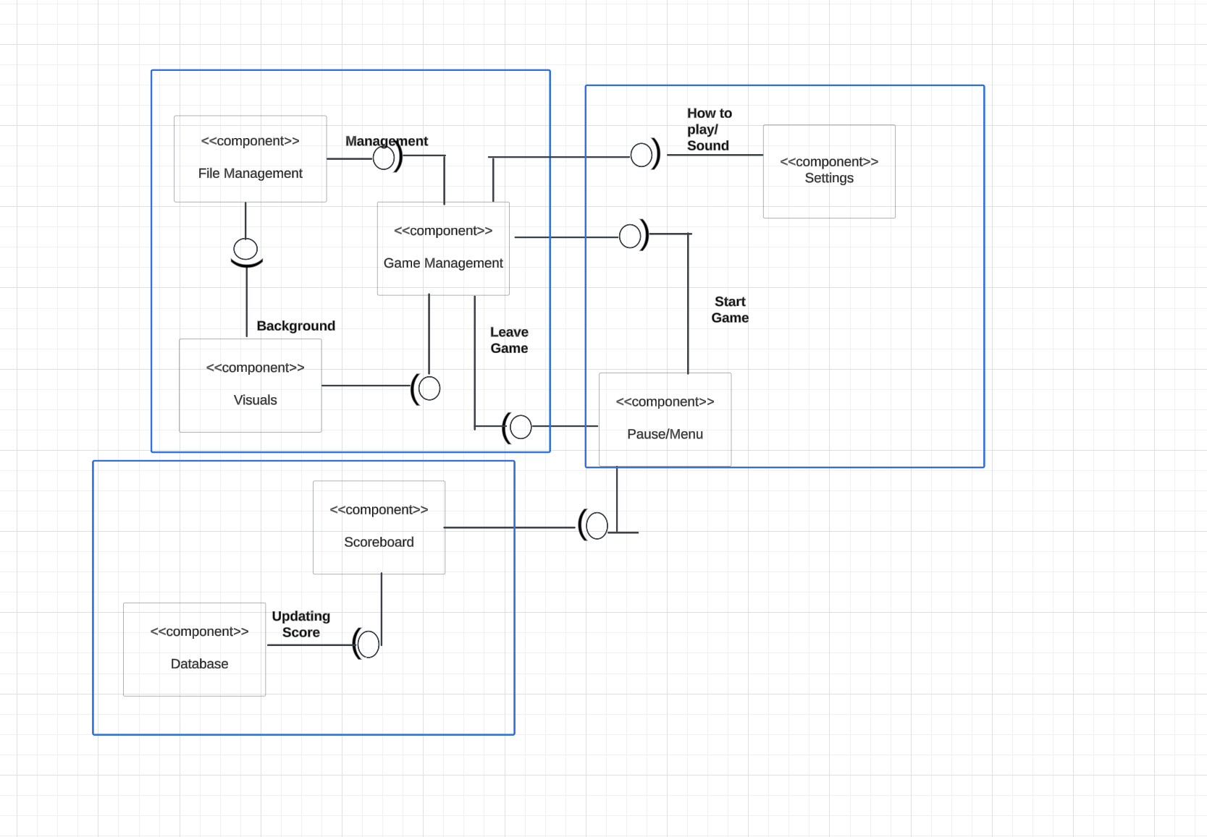
The model below is a MVC design pattern. Our team believed that the MVC model was a great fit for Carrot Quest because it is easier to extend if we want to add more features into the game but, it also simplifies the game to its main components. We can separate the components into 3 sections. One section consists of the backend. These are parts that the users can not see. The second section is the front end. These are codes that are the users interacts with. Then the last section is the database section. This is code related to the scores and scoreboard are put.

Hardware/Software
The core design of Carrot Quest will be developed using Java. Specifically, the game itself will be made with JavaScript. The game will be run in a web browser and use HTML to assist with the visuals within the game.
Carrot Quest hardware is very accessible so users can play the game easily. The keyboard and mouse will be used as an input/output tool for the game. The keyboard and mouse allow players to interact and play Carrot Quest. The mouse is used to navigate the menu selection and game over screen. Players can click the menu selection to start the game, view instructions, look at high scores, enable or disable music, and exit the game. In the end screen section players can submit a score, restart the game, and return to the main menu. While playing the game players can use the “A” and “D” keys or arrows on the keyboard to move the bunny.
The score system will be stored within a local database. As a result, the game does not need any internet even to see the scoreboard. However, this also means highscores are unique to each computer. In the future Carrot Quest, plans to make the scoreboard universal, allowing players to compete with other players across the world.

Persistent Data Management
Carrot Quest needs to store data in order to function. Carrot Quest stores the game instances and also stores player’s scores within a database using SQL. After completing the game, players will have the option to enter a 3-character name. The name submitted and the score will be saved into a database. The top 5 scores will be posted on the game’s leaderboard.
The game also stores data to help make the game run smoothly. Carrot Quest needs to be able to store background images, bunny character, music, and animations. These data are stored locally on the computer.

There is also temporary data in the game. For example, there are randomly spawning platforms and bombs. As the rabbit jumps higher into the sky, platforms that are far below become not visible to the player. Therefore the data is deleted to prevent lag in the game from too many entities. The same thing happens to the floating bombs that randomly spawn

Access Control and Security
As mentioned in the Hardware and Software mapping section, Carrot Quest does not require any internet connection. The game is able to function offline while still being able to access a web browser by utilizing local data on the computer. The data and code stored on the computer are directly put into the web browser which allows the browser to open.
Since the game doesn’t require an internet connection, there is no concern for any security leaks. This is because each computer will have its own data and no data is shared. The highscore feature will be unique for each computer.

Boundary Condition
Carrot Quest is a web based game which means that it does not require any installation. Players will open “Carrot Quest.html” file which will open the game. This game does not require any internet connection, so players are able to play the game on the go as long as they have access to a computer or laptop.
2.5.1 Initialization
Each time players open the game, a new instance of the game will load. In Carrot Quest players are not allowed to continue the game if they accidentally exit it. However, the game does save the score locally onto the computer. This ensures that player’s achievements will be tracked and they can continuously try to beat their high scores.

2.5.2 Termination
Players are able to terminate the game in 2 areas of the game. When players are at the main menu screen or game over screen they will see a button that says “exit”. If the uses click on the button the game will close and the tab that its in.
2.5.3 Errors
If the files can not be read the game will automatically close.

Subsystem Services

Game Logic and Design

Overview
The game will load the background of the sky and clouds along with a randomly placed platform and a rabbit the player will control. Should the player land on the highest platform, the screen shall scroll upwards and another platform will load, which the player will have to try to reach. On occasion, a bomb will also be generated in a random area that the player will have to avoid. The farther the player goes, the higher the score.

In-Game State Activity (use case diagram here)

“Full activity diagram” of play →in game → game over
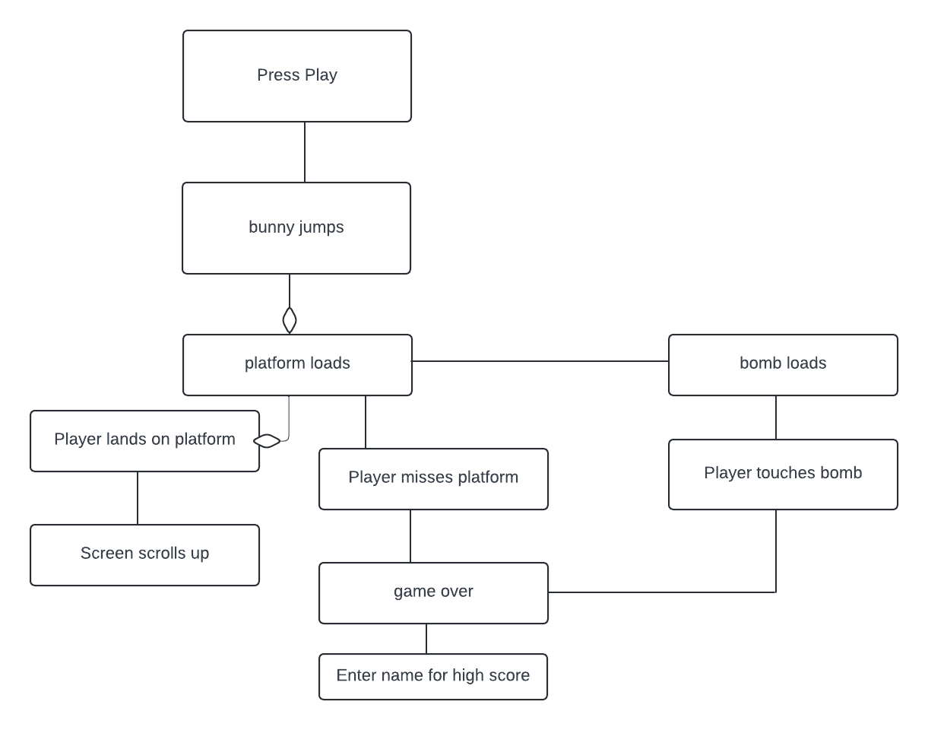

In-Game Scenarios
There are two scenarios the player will encounter. The first is to reach as many platforms as possible to get a high enough score. This is handled through the “function newPlatforms()” code in the carrotquest.js file. The other is to avoid bombs that occasionally may also be generated on a platform. This part is being handled through our “function placeObstacles()” code in the carrotquest.js file.

Continuous score accumulation
The score is counted the more and more platforms the player can reach. Once the player misses a platform or even interacts with a bomb, the game will be over. Whatever their total score becomes will be entered into the game's system once a name is given for the score to be associated with.

Sequence diagram updated
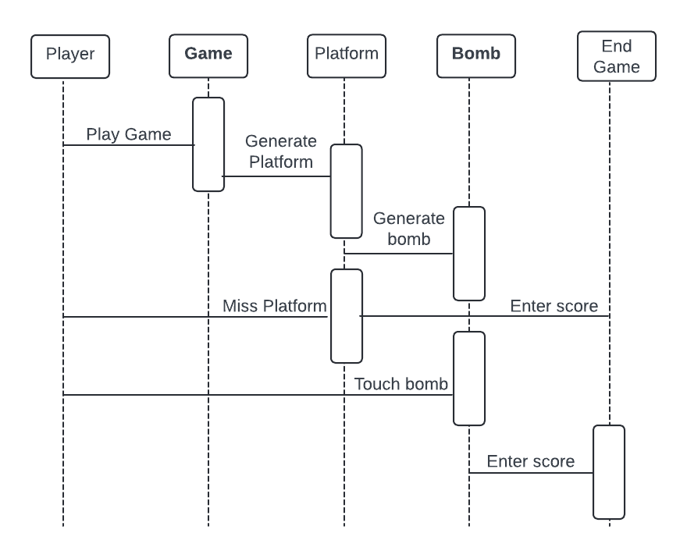

Death by Falling
Platforms are randomly generated throughout the game. Should the player reach the highest platform, the platforms will disappear once they go beyond the boundary of the screen. If by chance, the player is unable to reach the next platform and falls, they will have to enter their name in the text bar to register their score in the game.

Death by object bomb
Along with platforms, bombs are also generated, though only on occasion. In the possibility that the player interacts with the bomb, the character will die and it will be game over. They will then have to enter their name for the game to register their score in the system.

Pause - in regards to “player needs to leave to go do stuff.
Pressing the button “P” will allow the player to pause the game to do other tasks they are required to do. You are given the extra options to lower or raise the background music as well as lower and raise the bounce sound effect of the rabbit character. You are also given instructions on how to play the game and the option to leave the game should the player be done for the day.

Quit the menu/ continue.
By clicking “Return to Menu” the player can return to the main menu of the game and play again.

“Sequence Diagram” & “Deployment Diagram” with states objects and variables

Detailed Design

Properties of the Game

Player
The player character is a rabbit designed with directional sprites (rabbit-right.png and rabbit-left.png). This design ensures fluid animations when moving left or right. The character’s size is fixed at 100x100 pixels, balancing visibility and agility on screen. The rabbit’s mechanics include responsive controls for jumping, falling, and horizontal movement, all governed by physics-based dynamics.

Platforms

Platforms are procedurally generated entities essential for vertical progression. Each platform is sized at 450x250 pixels, ensuring consistent spacing and manageable difficulty for players. Platforms are dynamically created as the player ascends, with collision detection allowing the character to bounce upward upon contact.

Bombs
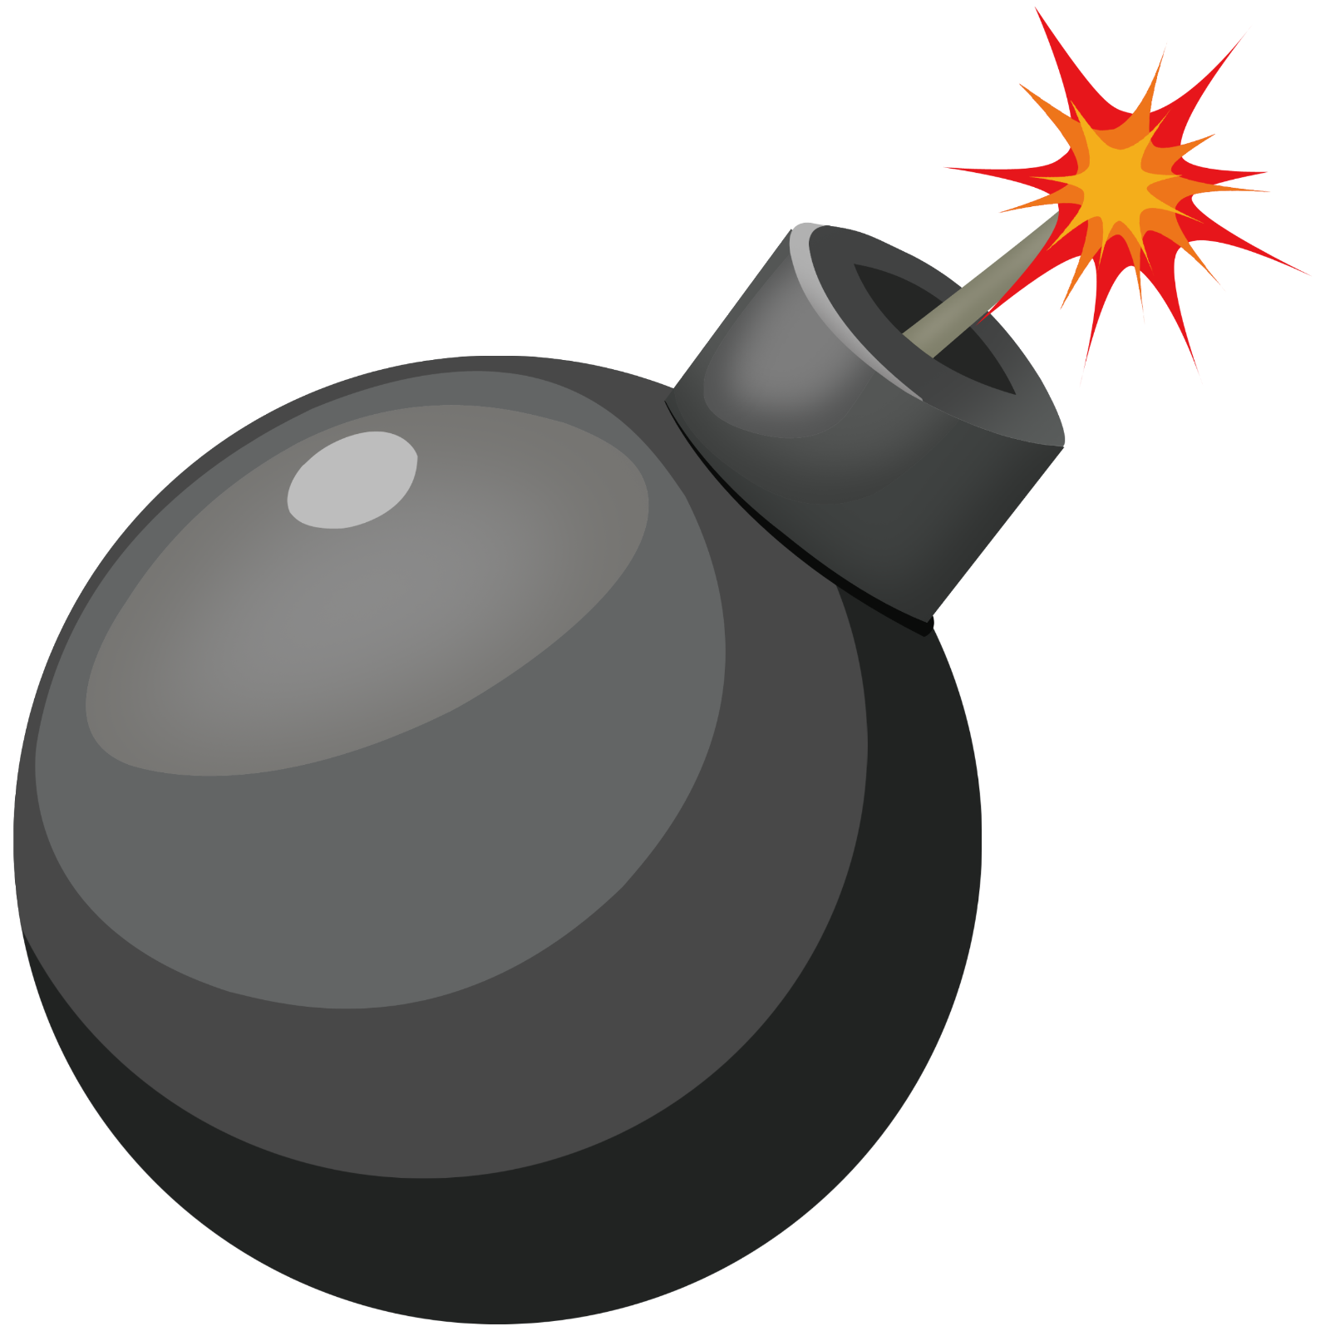
Bombs are the primary obstacles in the game, positioned randomly within the game area to challenge the player’s movements. Measuring 50x50 pixels, these objects add a layer of difficulty, as colliding with them results in an immediate game over.

Scenario
The gameplay scenario revolves around ascending platforms while avoiding bombs. The vertical progression mechanic encourages players to strategize their movements, balancing risk and reward as they aim for higher scores.

Background

The game uses a vertically scrolling video (CarrotQuestBackground.mp4) as the background. This seamless visual loop adds depth and complements the gameplay's theme of continuous upward movement.

Score
The score is directly linked to the player’s height. As the player ascends, the score increases proportionally. This simple yet effective scoring system incentivizes progress and provides a competitive edge through leaderboard integration.

Difficulty
The game maintains static difficulty, with challenges arising from random platform placements and bomb obstacles. This approach ensures consistent engagement while keeping the gameplay fair for players of varying skill levels.

States
The game transitions between four main states: Menu, Playing, Paused, and Game Over. Each state controls specific aspects of gameplay, ensuring smooth transitions and clarity for the player.

Methods of Design

Score based on height climbed.
The player gains a set amount of points based on how high they climb. The score is directly tied to how high they climb, with no modifiers based on how many platforms they touch or number of bounces.

Game loops
The game loop uses requestAnimationFrame to handle rendering, physics, and state updates. This ensures consistent performance and smooth gameplay, even on devices with varying capabilities.

Event listeners keyboard
Event listeners capture player inputs such as arrow keys for movement and 'P' for pausing the game. These inputs are processed in real-time, ensuring immediate feedback and responsiveness.

Background
Each of our different windows uses its own background. These are loaded out of the game files.

Sounds
The game integrates three sound files for a more dynamic audio experience: one for the main menu, one for in-game background music, and one for platform interactions.

Menus
The game features two menus, a main menu and a pause game menu. The main menu is reached when launching the game, returning to the main menu after viewing the instructions or high scores, or after ending a run of the game. The pause menu is accessed during a run of the game and allows the player to exit the run, view instructions, and resume.

Buttons
Interactive buttons are used across the game’s menus for navigation and control. These buttons are designed to be accessible and visually distinct.

Game Design

Functions
The game’s functionality is driven by several core functions, each designed to ensure seamless gameplay and proper management of game elements. The placePlatform() function is responsible for dynamically creating and positioning platforms within the game. It calculates platform placement based on the player’s current height and procedural generation algorithms to ensure variability and balance in platform spacing.

The placeObstacles() function adds an additional layer of difficulty by introducing bombs randomly into the game area. This randomness increases replayability, as players must adapt to new challenges during every game session. This function works in tandem with the platform generation to ensure obstacles are placed without obstructing essential gameplay paths excessively.

The update() function serves as the heart of the game’s logic. It is responsible for continuously rendering the game’s components, updating the physics engine, and managing the player’s interactions with platforms, bombs, and other elements. This function operates within the main game loop, utilizing requestAnimationFrame to ensure smooth performance and responsiveness.

Additional functions such as collision detection handle interactions between the rabbit and other objects, determining outcomes like bouncing, scoring, or triggering game-over states. These functions are optimized to reduce computational overhead, allowing the game to maintain a high frame rate even with increasing complexity.

Objects
The game employs an object-oriented approach to represent key elements, such as the rabbit, platforms, and bombs. Each object is encapsulated with properties and methods tailored to its role in the game.

The rabbit object includes attributes like position, velocity, and sprite orientation. Methods within the object control the rabbit’s movements, including jumping and horizontal navigation. The physics properties, such as gravity and jump force, are also defined here, enabling realistic and consistent movement.

The platform objects are dynamically generated and managed as part of an array. Each platform object includes properties for position, size, and collision boundaries. These properties are used to detect when the rabbit lands on a platform and trigger the bounce mechanic. Platforms also have methods for updating their positions relative to the scrolling background.

The bomb objects are similarly defined, with properties for position and size, and methods for random placement and collision detection. The game dynamically adds or removes bomb objects based on the player’s progress, ensuring memory-efficient gameplay.

By encapsulating these elements into objects, the game achieves modularity, simplifying future updates or additions. For example, new obstacles or character enhancements can be integrated without disrupting existing game mechanics.

Methods

Place platform
The placePlatform() method is responsible for calculating the position and placement of new platforms during gameplay. It ensures that platforms are distributed evenly and logically to allow for smooth gameplay progression. This method dynamically adjusts the spacing between platforms based on the player’s vertical progression, preventing unmanageable gaps or clustering. The function integrates procedural generation algorithms to vary the platforms’ positioning across different game sessions.

New platform
The newPlatform() method creates platform objects dynamically as the player ascends. This method constructs the platform’s properties, such as size, position, and collision boundaries, and inserts the platform into the game’s active objects array. The function works in conjunction with the game loop to monitor when new platforms need to be generated

Place object
The placeObject() method is used to position bomb obstacles within the game area. It employs randomization algorithms to strategically place bombs in locations that challenge the player while maintaining fairness. The method also checks for potential conflicts with platform positions, ensuring that bombs do not block necessary gameplay paths.

New object
The newObject() method handles the creation of new bomb objects during gameplay. It defines the properties of each bomb, such as its size and position, and initializes them into the game environment. This method is triggered dynamically based on the player’s progression and incorporates procedural logic to prevent predictability, maintaining the element of surprise and challenge.0

Player

Vertical Movement <<Access Matrix for this >>

Horizontal character movement <<Access Matrix for this >>

bounce<<Access Matrix for this >>

GUI Design

Description and Image of Components

Main page
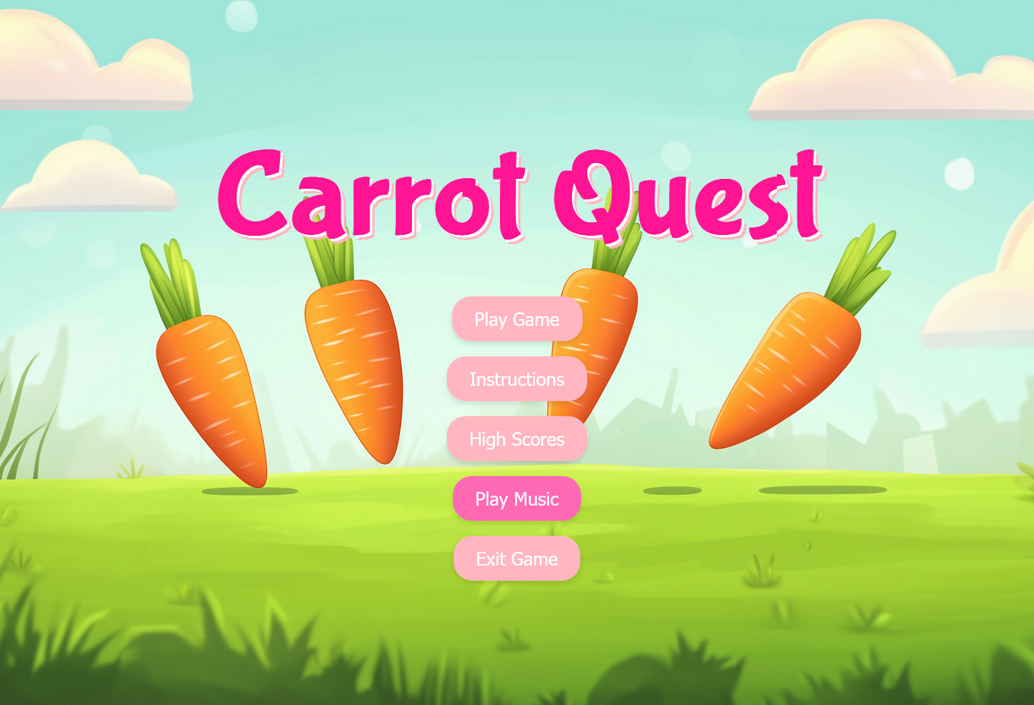
The main menu serves as the entry point to the game, providing access to instructions, high scores, and start options.

Description and Image of Components

Info.
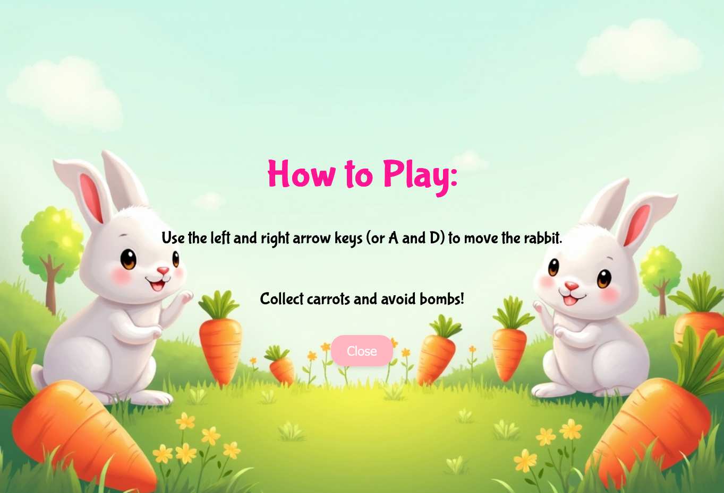
The instructions page outlines game controls and objectives, ensuring players understand the gameplay mechanics.

Description and Image of Components

Highscore
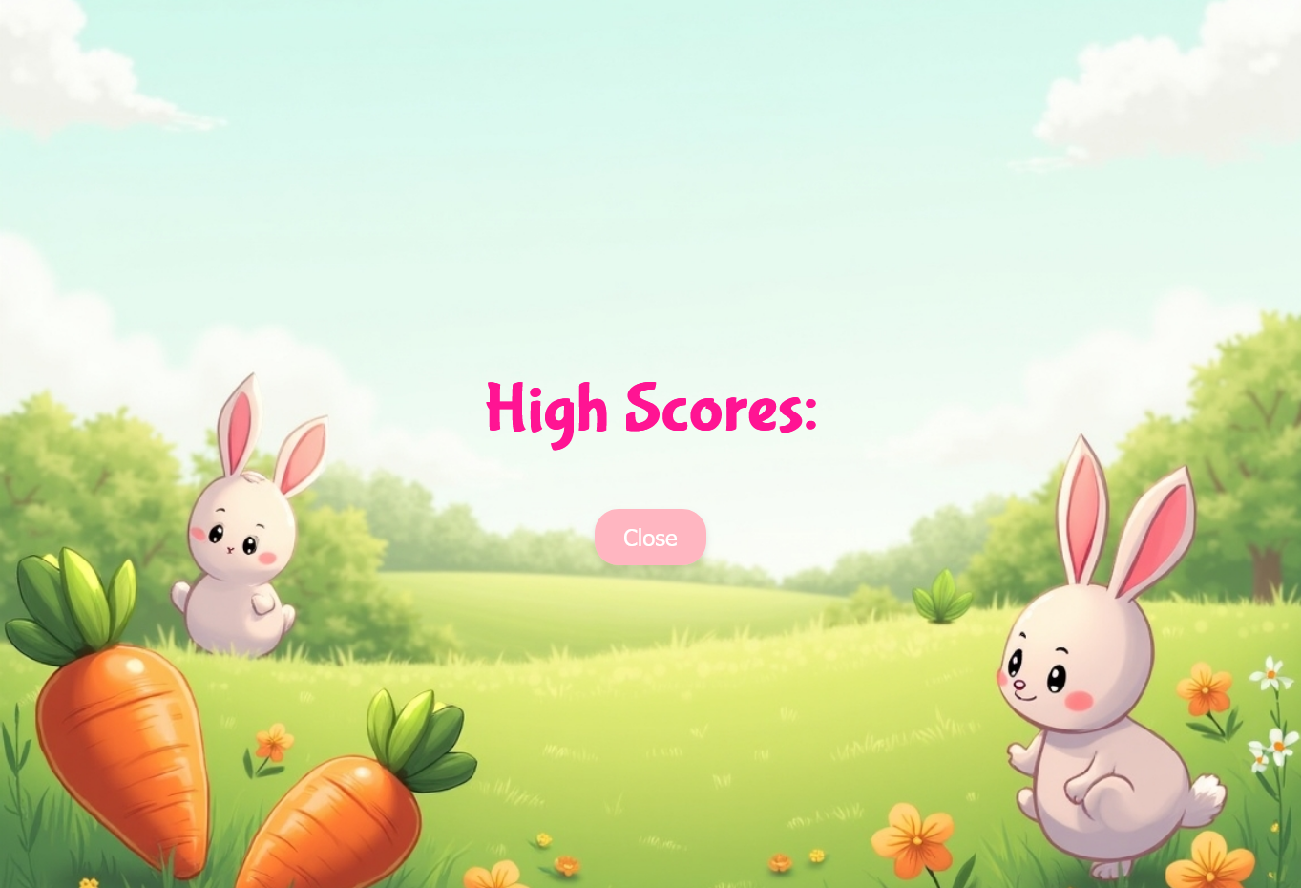
The high score screen displays a leaderboard of top scores.

Description and Image of Components

Game screen

The in-game interface shows the players current score and provides access to pause functionality.

Description and Image of Components

Game over
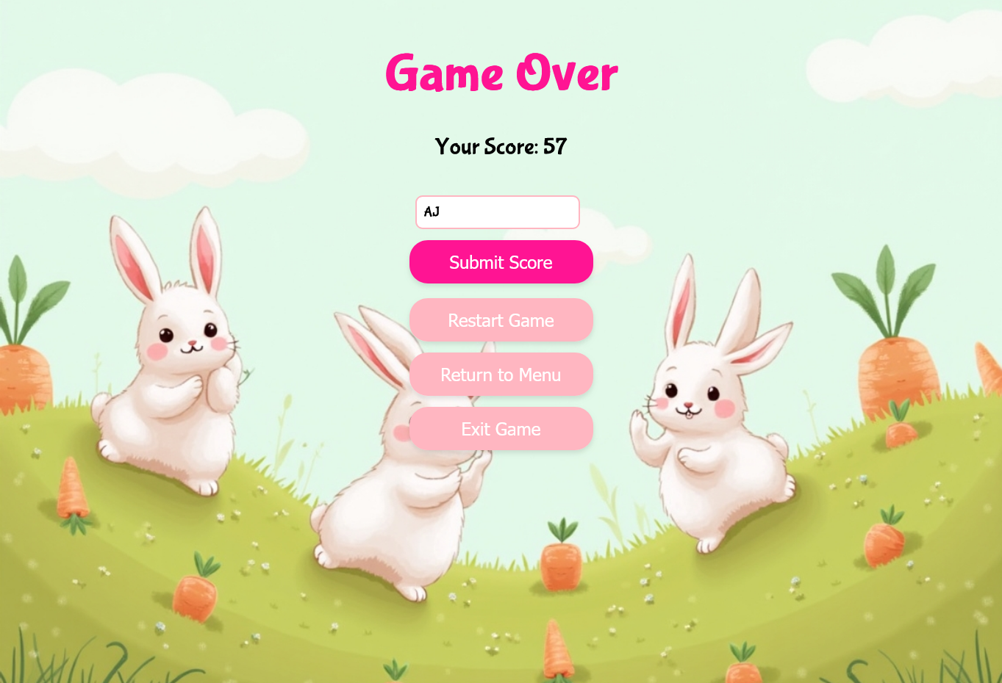
The Game Over screen displays the final score and offers options to restart or return to the main menu.

      - Use case for game over “Boundary Condition

Description and Image of Components

Restart & Exit
The player may choose to restart or exit to the main menu from this screen.

      - Use case for restart & Exit “Boundary Condition

GuI Class Design

Description
The GUI (Graphical User Interface) design in Carrot Quest ensures that players can interact with the game intuitively and efficiently. The design incorporates multiple screens, including the main menu, gameplay interface, pause menu, and game-over screen. Each screen is structured to present information clearly and provide seamless transitions between states. The GUI components are modular, enabling easy updates and the addition of new features without impacting the game’s core functionality.

The visual elements, such as buttons and text boxes, are styled using CSS to ensure consistency and responsiveness across different devices. The design prioritizes accessibility, with clear fonts, contrasting colors, and intuitive layouts that make navigation straightforward for players

“Class Design/Function Design Diagram”

“Activity Diagram Based on last”

Sound Design

Sound effects
Sound effects in Carrot Quest are designed to provide players with auditory feedback that enhances the overall gaming experience. Key sound effects include:
- Platform Interaction: A bounce sound plays whenever the rabbit lands on a platform, reinforcing the physics-based mechanics and rewarding successful jumps.
- Bomb Collision: A distinct explosion sound triggers when the player collides with a bomb, emphasizing the game-over event.
- Button Clicks: Subtle clicking sounds accompany button interactions on menus, providing tactile feedback for user actions.

These effects are implemented using preloaded audio files and triggered through JavaScript event listeners linked to specific in-game actions. The sound files are optimized for size and performance, ensuring minimal impact on game loading times.

Music
Our game features a dynamic music system with different tracks for specific stages of the player’s journey:

- Main Menu: A light and inviting track plays in the background, setting a welcoming tone for new players.
- Gameplay: An energetic and rhythmic track plays during the game to maintain engagement and match the pacing of the rabbit’s vertical ascent.
- Game Over: A somber tune accompanies the game-over screen, providing closure while encouraging players to try again.

The music files are looped seamlessly to avoid disruptions and are controlled through an audio management system. Players can adjust the music volume or mute it entirely via the pause menu, offering customization based on personal preference.

Backend

Highscore save states
The backend for carrot quest is designed to manage and persist high scores,ensuring a competitive experience for players. The highscore system records:

- Player Name: Captures the name entered by the player to associate with their score
- Score: Tracks the total score achieved during gameplay.
- Timestamp: Automatically records the date and time of the score achieved.
This data is stored in a SQLite database, enabling efficient and lightweight storage, upon game over, the frontend sends the player’s score and name to the backend using JavaScript, which then updates the database. The backend is designed to handle multiple simultaneous requests, ensuring smooth operation during high player activity.

Database
The database schema is simple yet robust, designed to store and retrieve highscore data efficiently. The structure includes the following table:

CREATE TABLE IF NOT EXISTS high_scores (
id INTEGER PRIMARY KEY AUTOINCREMENT,
player_name TEXT NOT NULL,
score INTEGER NOT NULL,
date_achieved DATETIME DEFAULT CURRENT_TIMESTAMP
);
Key features of the database implementation:

- Primary Key: Each score entry is assigned a unique ID to ensure traceability.
- Validation: Data types and constraints prevent invalid entries, such as null scores or empty player names.
- Timestamping: The date_achieved column uses a default value of the current timestamp to automatically record when a score is added.
The database is integrated with the game through SQL queries embedded in JavaScript. For instance, retrieving the top scores for display on the leaderboard involves a query like:

SELECT player_name, score, date_achieved
FROM high_scores
ORDER BY score DESC
LIMIT 10;

This query ensures that only the highest scores are shown. The backend also includes functionality for sanitizing inputs to prevent SQL injection, ensuring security and data integrity.

